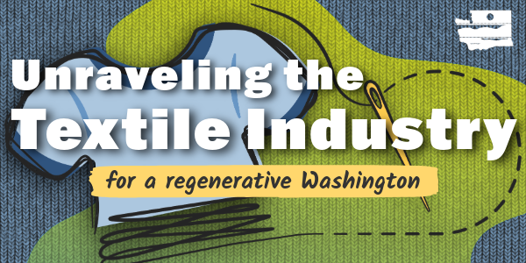
The Washington State Recycling Market Development Center part of the Department of Ecology, dedicated extensive time and collaborative effort to researching, building partnerships, and establishing a trusted network of local, national, and global textile industry leaders. Supported by a collaborated effort through the Textile Co-Design team, this work culminated in a four-part webinar series: Unraveling the Textile Industry for a Regenerative Washington. Through radical collaboration, we level-set, defined, and weaved the global complexities of the textile industry into a regional context. This document provides the summary for Webinar #3: Hemmed in to Cutting Loose – Adopting New Innovations, May 13th 10am - 12:30pm PST.
Goal: Explore cutting-edge technologies enabling circular textile practices while addressing infrastructure, logistical, and economic barriers to scaling innovation.
Outcomes:  - Learn from 5 case studies in textile tech (fiber ID, sorting, recycling)  - Understand physical and digital infrastructure needs and barriers  - Identify costs, policy gaps, and implantation roadblocks | Key Topics:  - Tech innovations in textile circularity  - Concrete, scalable examples relevant to Washington  - Infrastructure and investment needs

Recycling Market Development Center:
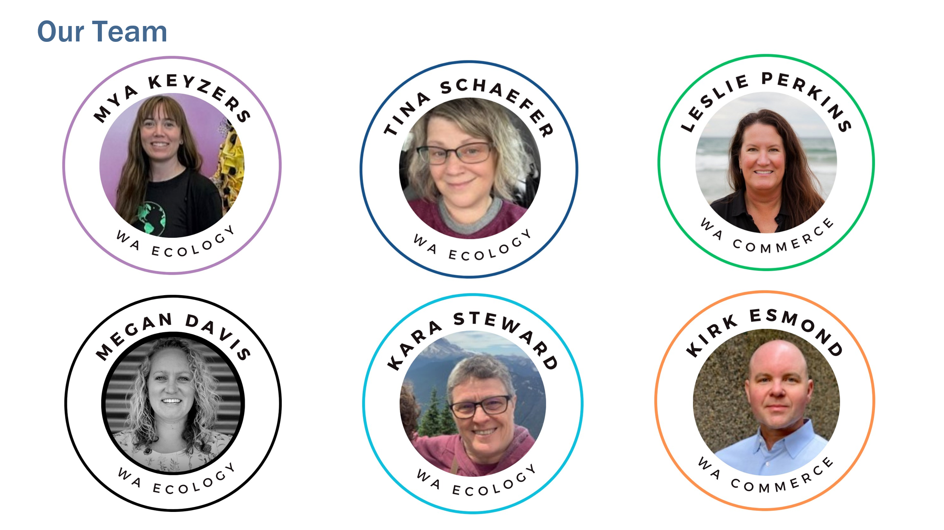
Newsletter

Hosts:
- Timothy Parent fashion advocate for Reforme U | Home
- Carly Mick, Director of Sports Product Design, University of Oregon.
Sorting Tech:
- Brian Iezzi, Founder, Fibrarcode
  - Organization: Fibrarcode
  - Contact: bciezzi@umich.edu

- Constanza Gomez, CEO, Sortile
  - Organization: Sortile
  - Contact: cgomez@sortile.co

Materials Exchange Platform:
- Stephanie Benedetto, CEO, Aloqia
  - Organization: Aloqia
  - Contact: stephanie@queenofraw.com

New Innovations Through Academics:
- Hang Liu, Associate Professor, WSU & Patricia Townsend, Associate Professor, WSU
  - Organization: Washington State University Metropolitan Center for Applied Research and Extension
  - Textiles Work
  - Contact: patricia.townsend@wsu.edu & hangliu@wsu.edu

Textile-to-Textile Recycling:
- Scott Hamlin, CEO, Looptworks
  - Organization: Looptworks
  - Contact: scott@looptworks.com

Key Takeaways:
- Digital labeling is here and is crucial for circularity.
- Circular design for labeling is essential to the system.
- Textile recycling scalability relies on effective, accurate, and affordable sorting.
- Promising technologies need further development, better processes, and standards.
- Circularity is active in the Pacific Northwest, with viable waste stream diversion and circular fiber supply chains.
- Use technology to support people, planet, and profit (triple bottom line).
- Embrace the use, reuse, remake, and rethink approach for existing textiles.
- Recognize the abundance of existing clothing—we already have enough for multiple generations.
- Academia is a valuable partner for textile recycling and sustainability initiatives.
Other Resources:
- Slide deck for webinar #1 Level Setting
- Slide deck for webinar #2 Business Transformation
- Slide deck for webinar #3 Adopting New Innovations
- Slide deck for webinar #4 Advocacy & Coalition Building.
- Contacts and key takeaways for webinar #1 Level Setting
- Contacts and key takeaways for webinar #2 Business Transformation
- Contacts and key takeaways for webinar #4 Advocacy & Coalition Building.
- Megan Davis megan.davis@ecy.wa.gov
- Mya Keyzers mya.keyzers@ecy.wa.gov

